Committee Vision for OLMP Outdoor Space ​
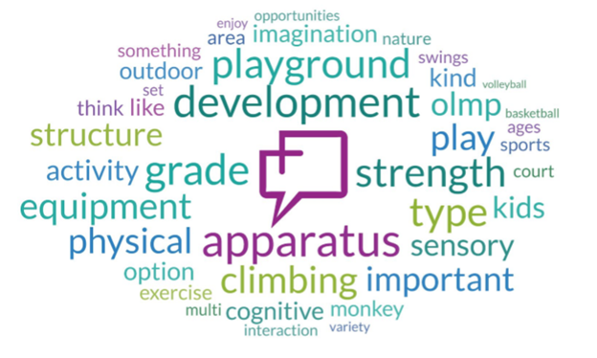
Vison is to create a space with a full range of outdoor activities that is useable during all seasons. Designed primarily for older children in the grade 5, 6, 7, 8 and up age group, it should be available for use by the school and all other community users. Focused on fitness, climbing, physical movement, multi user stations and social interaction while offering some inclusivity for those who need it. The cost must be reasonably achievable and the equipment must be safe and long lasting.

Draft Project Scope (to be further developed)
For a number of years Our Lady of Mount Pleasant school (OLMP) has been unable to offer students a full range of outdoor activity space, the existing basketball court requires updating, and the students have had little opportunity to engage in active play within the school grounds during recess. Due to educational funding restrictions OLMP has been unable to secure all funds required to expand the pad or provide play equipment for students.

Phase 1:​ Improve current infrastructure (basketball court), to ensure students have a designated, safe and robust space that they can utilise to develop physical and mental developmental skills. This will include:
· Adding 4 basket ball hoops,
· A tether ball game and
· Games painted on the existing surface.
Phase 2:​ Construct a larger interactive playground area that will support increased opportunities to develop positive social skills, physical activity, and cognitive skills.
This will include:
- site preparation,
- development of a fall surface and
- installation of selected playground & fitness equipment.
Prior to proceeding with fundraising the following criteria must be completed:
- Options of equipment based on the vision will be reviewed by the playground committee
- The committee by consensus will select the type of equipment to be obtained
- Estimated cost quotes must be obtained for site prep, surface, installation and equipment
- Committee will develop a fundraising plan to reach the agreed upon goal
- Committee will implement the fundraising plan and continue to review progress towards the goal
Prior to proceeding with each phase of development the following criteria must be completed:
· Fundraising goal must be met, there must be sufficient funds to cover the cost of each phase prior to proceeding
· Final review of equipment options based on the vision will be reviewed by the playground committee (is there specific criteria that must be met?)
· The committee by consensus will select the exact type of equipment to be obtained
· Detailed cost quotes must be obtained for site prep, surface, installation and equipment
· Committee must determine review costs to ensure adequate funds are available
· Final review of selection and costs should be reviewed by the committee before submitting for school board approval
Recognition – Is there recognition that can be offered to major donors?
Timelines ?

Draft Fundraising/ Letter of support - click here to access

Playground Options and Estimated Costs
1. The Crab Trap
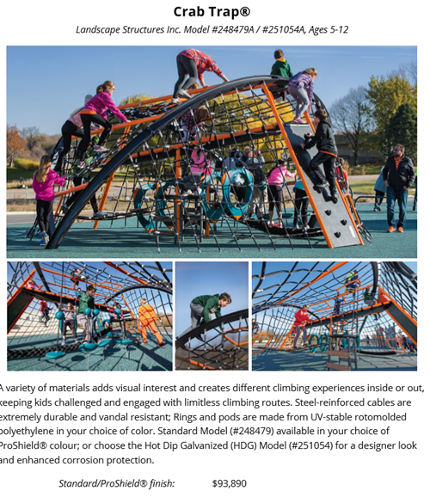
Estimated Costs
Equipment cost $94’000
1000 square feet site prep - $4000
Rubber paved surface $15’000
Installation $ 10’000
Total $123’000

2) Canadian Recreation Solutions Playground (or version of)
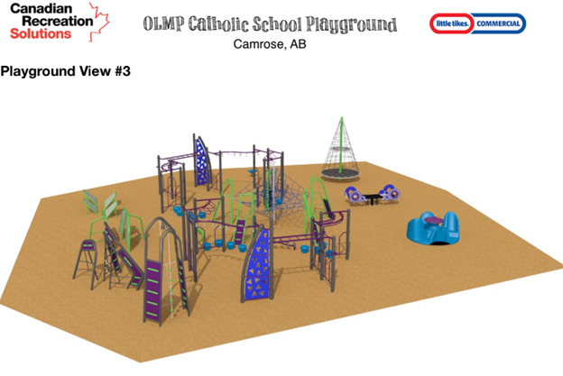
Estimated Costs
Equipment cost $110’000
5600 square feet site prep - $22’400
Fall material $20’000
Installation $ 10’000
Total $162’400

3) Blue Imp
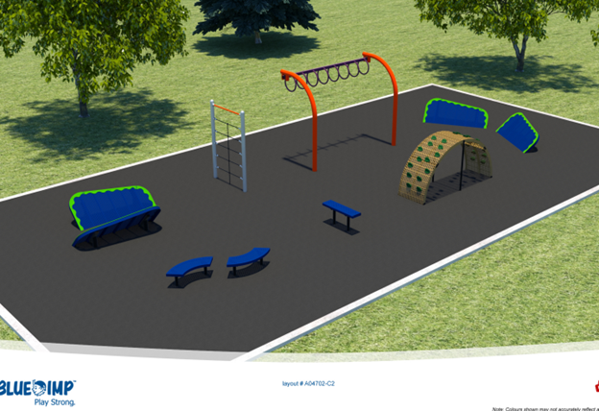

Estimated Costs
Total (with loose fall material) based on quote Total $36,233

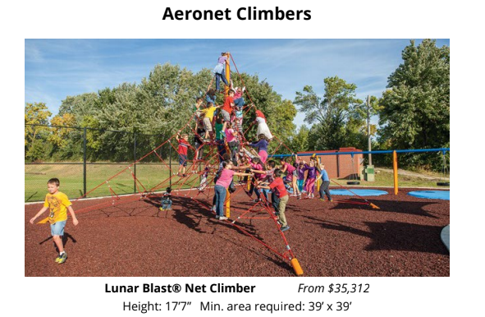

Estimated Costs
Equipment cost $35’300
1500 square feet site prep - $6000
Rubber paving fall material $22’500
Installation $ 10’000
Total $73’800

