RAP Student Forms



**Our Lady Mount Pleasant School**

**Kevin Elliot - Off Campus Coordinator**

Phone: (780) 672-2975 (school) Fax: (780) 672-4747

Email: [kevin.elliot@eics.ab.ca](mailto:kevin.elliot@eics.ab.ca)

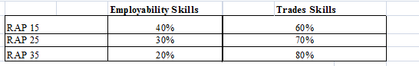

**REGISTERED APPRENTICESHIP PROGRAM (RAP)**

**Required Documents**

**It is your responsibility to ensure that the following are handed in and completed in a timely manner.**

|  |  |  |  |
| --- | --- | --- | --- |
| **\*\*\*\*\*\*\*Before** the student enters their respective job site they must have completed:  **HCS3000 (mandatory)** | | **Hand In Date** | **✓** |
| **Pg #** | Orientation meeting (include right of refusal, confidentiality, WCB, hours of work) | **Before placement** |  |
| **17-18** | Parental Consent form | **Before placement** |  |
| **19** | Off – Campus Education Program Agreement Form  **Signed by employer, student, parent and Off-Campus Supervisor | **Before placement** |  |
| **ONLINE** | **\*\*Must complete ONLINE Apprenticeship Application at**  **TradeSecrets.alberta.ca once the placement has been confirmed**.  See instructions on page 7& 8 of this booklet. | **Once placement is confirmed** |  |
| **15** | Work Station Orientation Assignment Form | **1st week placement** |  |
| **16** | Work Site Safety Orientation Form | **1st week placement** |  |
| **11-12** | **Monthly Student self-evaluations** | **Monthly** |  |
| **13** | Monthly Timesheets | **Monthly** |  |
| **15-16** | ***Employer + Student Evaluation*** | ***Every 125 hours*** |  |
| **9** | Collect copy of Thank-You Letter | **End of placement** |  |

Kevin Elliot- Off Campus Education Coordinator

Our Lady Mount Pleasant Jr/Sr High School

Phone: (780) 672-2975 Fax: (780) 672-4747

Email: kevin.elliot@eics.ab.ca

**REGISTERED APPRENTICESHIP PROGRAM (RAP)**

***WHAT IS RAP? INFORMATION FOR EMPLOYERS***

|  |  |
| --- | --- |
| **OBJECTIVE** | The purpose of the Registered Apprenticeship Program is to provide students with the opportunity of begin accumulating apprenticeship hours in a trade, while working toward their **High School Diploma.** |
| **DESCRIPTION** | Students complete **125 hours for 5 credits** on a trial basis called an internship (usually completed in July). Following this period, if the internship is successful for both parties, the employer will apprentice the student and employ them for August and one semester (September-January OR February-June) on a full-time basis (approximately 40 hours per week). Employers may apprentice the student on a part-time basis (every morning OR every afternoon) and the student will attend school on a part-time basis for the entire school year. For every 125 hours worked, students earn 5 credits, to a maximum of 40 credits. Apprenticeship hours are accumulated as usual, and reported by the employer. |
| **WAGE** | Employers’ participation in the RAP Program should in no way affect their normal hiring practices and expectations. |
| **WCB** | Alberta Learning provides Workers’ Compensation coverage for student workers. |
| **HOURS OF WORK** | Students may work between **7:00 A.M. and 10:00 P.M.** seven days a week (Monday to Sunday). Employers’ exemption from minimum wage legislation and students’ coverage by Workers’ Compensation **apply only during these hours.** |
| **AGREEMENT** | Employers enter into an agreement with the student, the student’s parents or guardians and Elk Island Catholic School Division, covering the period of employment. The employer, for reference, should retain one copy of the completed agreement (RAP Contract) |
| **LEARNING PLAN** | Student’s duties should be discussed and agreed to by all parties. A Learning Plan will be discussed and defined noting student tasks and learning expectations. |
| **SUPERVISION** | The employer will directly supervise and control the work of the student during the work periods. The RAP coordinator will visit and/or contact the work site supervisor periodically for evaluation purposes. |
| **ASSESSMENT** | Employers are asked to complete an assessment of the student’s performance, for **every 125 hours** worked. Assessments must be sent to the Off-Campus RAP Coordinator or returned A.S.A.P. |
| **TRACKING HOURS** | Students are required to deliver or fax their hours and progress to their RAP coordinator monthly, initialled or signed by their supervisor in accordance with Alberta Education. This is essential for accurate distribution of school credits at reporting periods. Employers are also asked to assist the student with the upkeep of his/her blue book on a regular basis. |
| **CONTACT**  **COORDINATOR** | Please contact Off-Campus RAP Coordinator for the following:  ⏵Student accident – you will need to contact the RAP coordinator for the WCB number;  ⏵Student incident – the coordinator is aware (may choose to speak to the student **or** the employer may);  ⏵Student Problem (absence, initiative) – one which the school needs to be involved to resolve;  ⏵Student disobeys or ignores company rules or regulations;  ⏵Absence from work without having contacted the employer. |
| ***THANK YOU!*** *To you and your staff for the time and effort donated to this Program.* | |

Kevin Elliot- Off Campus Education Coordinator

Our Lady Mount Pleasant Jr/Sr High School

Phone: (780) 672-2975 Fax: (780) 672-4747

Email: kevin.elliot@eics.ab.ca

Responsibilities of the Off-Campus Education Student

To be eligible for an Off-Campus Education placement, the student must have completed the HCS 3000(Workplace Safety Systems) course and all registration documents. HCS 3010 (Workplace Safety Practices) and CTR 1010 (Job Preparation) are also recommended modules for Off-Campus Education. AG 3000 is the pre-requisite for the Green Certificate Program.

1. The student should recognize this learning experience as an opportunity to establish his/her credibility as a good worker. Employment experience, an employer reference, and high school credits are the rewards of this program. RAP students will also register hours towards their apprenticeship program.

2. As expected in any employment situation, the student must notify their supervisor of an absence prior to **every** occurrence.

**3. If the courtesy of reporting an absence is neglected, the off-campus contract may be terminated.**

4. The student recognizes the need for adequate training for any equipment, tools or machinery for student/employee use. The student understands their “Right of Refusal” to any task considered unsafe or when the student feels ill prepared to undertake an assigned task.

5. The student will recognize and respect the confidentiality of the workstation. Matters that pertain only to the workstation and staff will not be discussed outside the workstation. Genuine concerns regarding the workstation will only be discussed with the Off-Campus Education Coordinator.

6. If the student encounters an accident or injury while at the workstation, it **must** be reported immediately to the supervisor and then to the Off-Campus Education Coordinator.

7. The student accepts responsibility to maintain accurate and detailed “Time Sheets” or other Off-Campus Education documents as required.

8. The student accepts responsibility for transportation to and from the workstation.

9. Attendance and school work in other classes must not be affected by Off-Campus Education courses.

 Kevin Elliot- Off Campus Education Coordinator

School: (780) 672-2975

Fax: (780) 672-4747

Email: kevin.elliot@eics.ab.ca

**Off-Campus Education**

Responsibilities of the Employer /Workplace Supervisor

1. Provide an opportunity for the student to experience your hiring process and a “new employee orientation” informing the student of the performance expectations and safety regulations and protocols.
2. Provide adequate training for any equipment, tools or machinery that will be used by the student. Acknowledge the student’s “Right of Refusal” to any task the student considers unsafe or that he or she feels ill-prepared to undertake.
3. Provide supervision for the student, preferably a “job shadowing” situation until some basic routines are established.
4. Assist the students at the work site to do meaningful work according to their capabilities.
5. Ensure the worksite is “Occupational Health and Safety Act” compliant.
   1. **The on-site instructor / supervisor shall be designated as the person who has primary responsibility for the students’ health and safety while they are at the work station or work site.**
6. **Follow the “Off Campus Injury Protocol” in reporting any accident or injury involving the student on the work site. Contact the Off-Campus Education Coordinator within 24 hours.**
7. Report any on-going attendance problem to the Off-Campus Education Coordinator. The student may work between **7:00 a.m.** and **10:00 p.m.** on days agreed upon by the student (Parent/Guardian if applicable) and the workstation supervisor.
8. Offer comments and sign the student’s time sheet on a monthly basis before it is turned into the Off-Campus Education Coordinator.
9. Provide an evaluation of the student’s work habits and job performance skills (final evaluations required).
10. Will your business pay?

|  |  |  |
| --- | --- | --- |
| 1. Regular wage_________ | 2. Hourly rate____________ | 3. Honorarium____________ |
| 4. No Wage __________ |  | |

_______________________________ _______________________________ _______________

Employer / Workplace Supervisor Signature Date

(Please Print)

**We appreciate your support of the Off-Campus Education Program**

**Instructions on Applying Online for Your “Blue Book”**

1. Go to <http://tradesecrets.alberta.ca>
2. Click on “**Access Online Services**”



1. Click on “**Apply for AIT Programs and Services**”

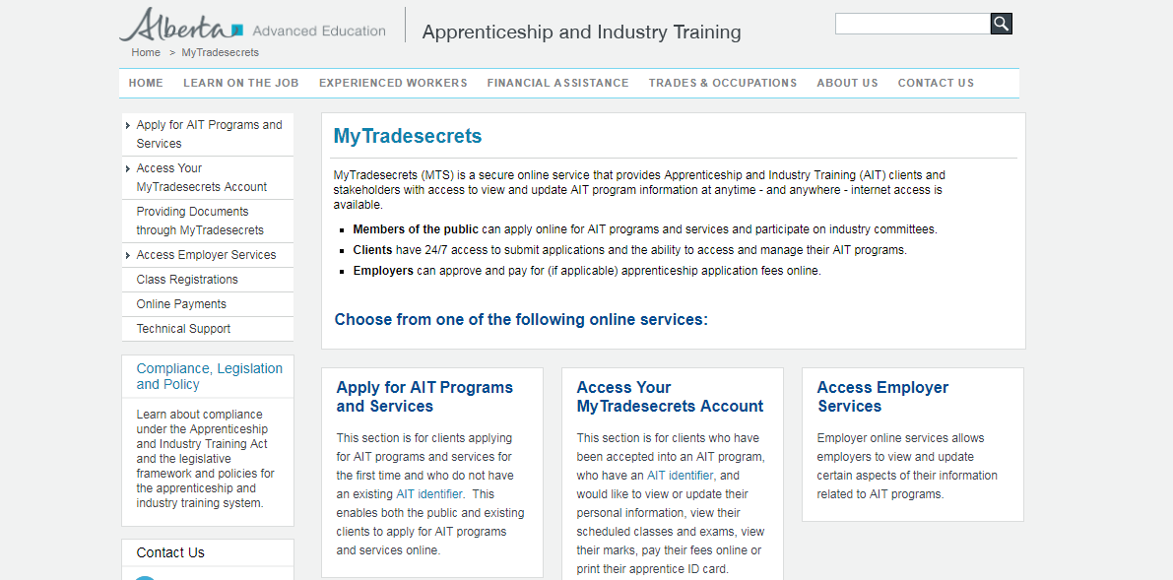

.

1. Click on “**Create an Account**”

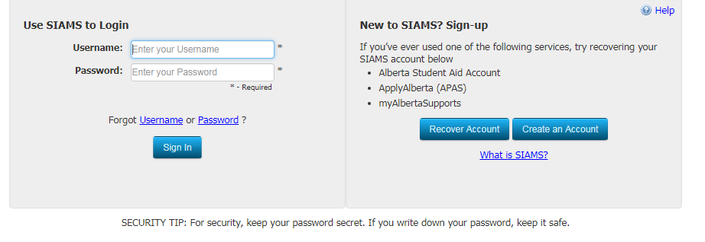

1. Sign back into “**Use Siams to Login**” once you have confirmed your account.
2. Follow prompts for “**Apprenticeship Application and Contract**”. You must have your employer information (address, number, supervisor name (journeyman), email address for paperwork, etc)

**THANK-YOU LETTER -- FROM STUDENT TO WORK SITE SUPERVISOR**

**Style:** Informal

**Purpose:** To express appreciation to your work site/work station supervisor for the learning opportunity and the training time provided to you.

Each paragraph in the thank-you note has a specific purpose.

* Salutation: e.g., Dear________________________________________________________  
  and/or staff.
* The first paragraph indicates the purpose of the letter; e.g., to thank the work site/work station supervisor for the opportunity to……
* The second paragraph indicates at least one specific reason why the “thank you” is given; e.g., that you enjoyed the placement, the things you learned, the people who were helpful.
* The third paragraph is a concluding paragraph underlining the sentiment of the letter.
* Close your letter with your signature, preceded by one of the following:
  + Sincerely
  + Cordially
  + Best Wishes
  + Respectfully yours

Return Address and Date

First Paragraph

Second Paragraph

Third Paragraph

Closing

Salutation

Source: Section 12: Off-Campus Education Handbook, Alberta Education, Alberta, Canada

**Example of Skills Checklist that must be filled out by employer (in your “blue book”)**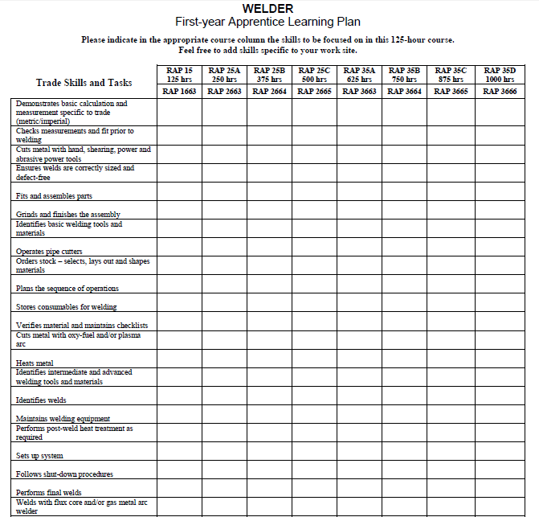



**STUDENT SELF-EVALUATION**

|  |
| --- |
| For each statement, provide some written comments. Remember that a “self-evaluation”  is what you think of what you did. Be honest with yourself. |

1. At the start of each day at the work site, I took steps to find out what was expected of me for that day.  
     
   ______________________________________________________________________________  
     
   ______________________________________________________________________________  
     
   ______________________________________________________________________________
2. I took pride in my work, and I always tried to do my best.  
     
   ______________________________________________________________________________  
     
   ______________________________________________________________________________  
     
   ______________________________________________________________________________
3. Once a task was assigned to me, I was able to work without supervision, although I may have had to ask for clarification or assistance.  
     
   ______________________________________________________________________________  
     
   ______________________________________________________________________________  
     
   ______________________________________________________________________________
4. If nothing was assigned by my supervisor or I finished early, I found something worthwhile to do.  
     
   ______________________________________________________________________________  
     
   ______________________________________________________________________________  
     
   ______________________________________________________________________________  
     
   ______________________________________________________________________________  
    (continued)
5. I learned to accept criticism about my work or efforts without being personally hurt. When criticism was made, I did not blame someone else or the fact that the instructions may have been unclear.  
     
   ____________________________________________________________________________________  
     
   ____________________________________________________________________________________  
     
   ____________________________________________________________________________________
6. I was enthusiastic and tried to convey the impression that I liked what I was doing.  
     
   ____________________________________________________________________________________  
     
   ____________________________________________________________________________________  
     
   ____________________________________________________________________________________
7. I recognized that my attendance at the work site was important and that people were counting on me to be there.  
     
   ____________________________________________________________________________________  
     
   ____________________________________________________________________________________  
     
   ____________________________________________________________________________________
8. If absent, I contacted both my job placement and the school.  
     
   ____________________________________________________________________________________  
     
   ____________________________________________________________________________________  
     
   ____________________________________________________________________________________
9. The one area where I think that I made the most improvement during my placement:  
     
   ____________________________________________________________________________________  
     
   ____________________________________________________________________________________  
     
   ____________________________________________________________________________________
10. The one area where I think that I could make further improvement:  
      
    ____________________________________________________________________________________  
      
    ____________________________________________________________________________________  
      
    ____________________________________________________________________________________  
      
    ____________________________________________________________________________________

Source: Adapted with permission from materials supplied by Calgary Roman Catholic Separate School District No.



Kevin Elliot : Off-Campus Education Coordinator

School: (780 ) 672-2975

Fax: ( 780 ) 672-4747

E-Mail: kevin.elliot@eics.ab.ca

**MONTHLY HOURS SUMMARY REPORT**

|  |  |  |  |  |
| --- | --- | --- | --- | --- |
| Student: | | | Month: | |
| Company: | | Supervisor: | | |
| Previous Hours: | Hours This Month: | | | Total Hours Accumulated: |

|  |  |  |  |  |  |  |
| --- | --- | --- | --- | --- | --- | --- |
| **Date** | **Day of Week** | **Time**  **In** | **Time**  **Out** | **Total Hours Today** | | **Duties/Tasks/Activities Performed** |
| **1** |  |  |  |  | |  |
| **2** |  |  |  |  | |
| **3** |  |  |  |  | |
| **4** |  |  |  |  | |
| **5** |  |  |  |  | |
| **6** |  |  |  |  | | **Supervisor’s Initial:** |
| **7** |  |  |  |  | |
| **8** |  |  |  |  | |
| **9** |  |  |  |  | |
| **10** |  |  |  |  | |
| **11** |  |  |  |  | |  |
| **12** |  |  |  |  | |
| **13** |  |  |  |  | |
| **14** |  |  |  |  | |
| **15** |  |  |  |  | |
| **16** |  |  |  |  | | **Supervisor’s Initial:** |
| **17** |  |  |  |  | |
| **18** |  |  |  |  | |
| **19** |  |  |  |  | |
| **20** |  |  |  |  | |
| **21** |  |  |  |  | |  |
| **22** |  |  |  |  | |
| **23** |  |  |  |  | |
| **24** |  |  |  |  | |
| **25** |  |  |  |  | |
| **26** |  |  |  |  | |  |
| **27** |  |  |  |  | |
| **28** |  |  |  |  | |
| **29** |  |  |  |  | |
| **30** |  |  |  |  | |
| **31** |  |  |  |  | | **Supervisor’s Initial:** |
| **Total Hours for Month:** | | | | |  | |

**Student Worker’s Compensation coverage through the Government of Alberta applies only**

**Between the hours of 7 a.m. & 10 p.m. (Monday to Friday)**

Kevin Elliot : Off-Campus Education Coordinator

School: (780 ) 672-2975

Fax: ( 780 ) 672-4747

E-Mail: kevin.elliot@eics.ab.ca

**MONTHLY HOURS SUMMARY REPORT**

|  |  |  |  |  |
| --- | --- | --- | --- | --- |
| Student: | | | Month: | |
| Company: | | Supervisor: | | |
| Previous Hours: | Hours This Month: | | | Total Hours Accumulated: |

|  |  |  |  |  |  |  |
| --- | --- | --- | --- | --- | --- | --- |
| **Date** | **Day of Week** | **Time**  **In** | **Time**  **Out** | **Total Hours Today** | | **Duties/Tasks/Activities Performed** |
| **1** |  |  |  |  | |  |
| **2** |  |  |  |  | |
| **3** |  |  |  |  | |
| **4** |  |  |  |  | |
| **5** |  |  |  |  | |
| **6** |  |  |  |  | | **Supervisor’s Initial:** |
| **7** |  |  |  |  | |
| **8** |  |  |  |  | |
| **9** |  |  |  |  | |
| **10** |  |  |  |  | |
| **11** |  |  |  |  | |  |
| **12** |  |  |  |  | |
| **13** |  |  |  |  | |
| **14** |  |  |  |  | |
| **15** |  |  |  |  | |
| **16** |  |  |  |  | | **Supervisor’s Initial:** |
| **17** |  |  |  |  | |
| **18** |  |  |  |  | |
| **19** |  |  |  |  | |
| **20** |  |  |  |  | |
| **21** |  |  |  |  | |  |
| **22** |  |  |  |  | |
| **23** |  |  |  |  | |
| **24** |  |  |  |  | |
| **25** |  |  |  |  | |
| **26** |  |  |  |  | |  |
| **27** |  |  |  |  | |
| **28** |  |  |  |  | |
| **29** |  |  |  |  | |
| **30** |  |  |  |  | |
| **31** |  |  |  |  | | **Supervisor’s Initial:** |
| **Total Hours for Month:** | | | | |  | |

**Student Worker’s Compensation coverage through the Government of Alberta applies only**

**Between the hours of 7 a.m. & 10 p.m. (Monday to Friday)**

**Employer’s RAP Evaluation**



**REGISTERED APPRENTICESHIP PROGRAM**

|  |  |  |  |  |  |  |  |  |  |  |  |  |  |  |  |  |  |  |  |
| --- | --- | --- | --- | --- | --- | --- | --- | --- | --- | --- | --- | --- | --- | --- | --- | --- | --- | --- | --- |
| STUDENT: ____________________________________________________________ | | | | | | | | | DATE: ______________________________________________________ | | | | | | | | | | |
| EVALUATED BY: _____________________________________________________ | | | | | | | | | | COMPANY: _________________________________________________ | | | | | | | | | |
| HOURS TO DATE (as previously reported): HOURS WORKED (this reporting period) From___________ To: _____________=__________HRS | | | | | | | | | | | | | | | | | | | |
| ***COODINATOR’S USE ONLY*** | | | | | | | | | | | | | | | | | | | |
| Intern | | 15a | 25a | | 25b | 25c | | 35a | | | 35b | 35c | | | 35d | | **TOTAL HRS.** | | |
| **Rate the student by indicating the number that best describes the student, to date N/A = Not Applicable** | | | | | | | | | | | | | | | | | | | |
| **4 – Met all** Work Requirements | | | | **3 = Met Most** Work Requirements | | | **2 = Met Minimum** Work Requirements | | | | | | | **1 = Did Not Meet** Work Requirements | | | | | |
| **EMPLOYABILITY SKILLS** | | | | | | | | | | | | | | | | **Student** | | **Supervisor** | |
| 1. | Is able to identify potential health and safety hazards and appropriate response actions 4 3 2 1 N/A | | | | | | | | | | | | | | |  | |  | |
| 2. | Uses correct safety equipment at all time 4 3 2 1 N/A | | | | | | | | | | | | | | |  | |  | |
| 3. | Reports all injuries and safety concerns 4 3 2 1 N/A | | | | | | | | | | | | | | |  | |  | |
| 4. | Maintains a safe work environment 4 3 2 1 N/A | | | | | | | | | | | | | | |  | |  | |
| 5. | Actively works as a member of one or more work teams 4 3 2 1 N/A | | | | | | | | | | | | | | |  | |  | |
| 6. | Accepts praise, advice, and constructive criticism 4 3 2 1 N/A | | | | | | | | | | | | | | |  | |  | |
| 7. | Communicates effectively with management and co-workers 4 3 2 1 N/A | | | | | | | | | | | | | | |  | |  | |
| 8. | Demonstrates adaptability and flexibility in performing tasks 4 3 2 1 N/A | | | | | | | | | | | | | | |  | |  | |
| 9. | Displays suitable attire and hygiene for the job 4 3 2 1 N/A | | | | | | | | | | | | | | |  | |  | |
| 10. | Dependable, punctual for work 4 3 2 1 N/A | | | | | | | | | | | | | | |  | |  | |
| 11. | Shows interest and is eager to learn new job skills 4 3 2 1 N/A | | | | | | | | | | | | | | |  | |  | |
| 12.  3.3. | Demonstrates a strong and positive work ethic 4 3 2 1 N/A | | | | | | | | | | | | | | |  | |  | |
| 13.  5. | Demonstrates positive initiative and is self starter 4 3 2 1 N/A | | | | | | | | | | | | | | |  | |  | |
|  | | | | | | | | | | | | | **TOTALS** | | |  | |  | |
| **TRADES SKILLS** | | | | | | | | | | | | | | | | | |  |  |
| 1. | Asks appropriate work related questions 4 3 2 1 N/A | | | | | | | | | | | | | | |  | |  | |
| 2.  1. | Has sufficient knowledge to complete most assigned tasks 4 3 2 1 N/A | | | | | | | | | | | | | | |  | |  | |
| 3.  2. | Identifies materials appropriate for completion of most tasks 4 3 2 1 N/A | | | | | | | | | | | | | | |  | |  | |
| 4.  4. | Selects correct and appropriate tools, equipment and/or processes for task completion 4 3 2 1 N/A | | | | | | | | | | | | | | |  | |  | |
| 5. | Uses correct techniques to complete most tasks 4 3 2 1 N/A | | | | | | | | | | | | | | |  | |  | |
| 6. | Is able to perform the following trade-specific skills/tasks assigned ***(list below*)** | | | | | | | | | | | | | | | | |  |  |
|  | A. 4 3 2 1 N/A | | | | | | | | | | | | | | |  | |  | |
|  | B. 4 3 2 1 N/A | | | | | | | | | | | | | | |  | |  | |
|  | C. 4 3 2 1 N/A | | | | | | | | | | | | | | |  | |  | |
| 7. | Meets basic levels of expertise for the tasks assigned 4 3 2 1 N/A | | | | | | | | | | | | | | |  | |  | |
| 8. | Understands and demonstrates safe clean up procedures 4 3 2 1 N/A | | | | | | | | | | | | | | |  | |  | |
|  | | | | | | | | | | | | | **TOTALS** | | |  | |  | |

***Supervisor’s comments are most helpful to the student:*** Please use reverse page

**SIGNATURES: NOTE: Please ensure the student has had an opportunity to view and sign this document.**

|  |  |  |
| --- | --- | --- |
|  |  |  |
| **RAP Student** | **Supervisor** | **RAP Coordinator** |

**Please attach the First Year Apprenticeship Learning Plan for the pertinent trade from the Off-Campus Handbook: Section 9, Pages 118 to 150**

**Supervisor Comments: __________________________________________________________________________**

**______________________________________________________________________________________________**

**______________________________________________________________________________________________**

**______________________________________________________________________________________________**

**______________________________________________________________________________________________**

**______________________________________________________________________________________________**

**______________________________________________________________________________________________**

**______________________________________________________________________________________________**

**______________________________________________________________________________________________**

**______________________________________________________________________________________________**

**Student Reflections:**

**Things I learned this month:_____________________________________________________________________**

**______________________________________________________________________________________________**

**______________________________________________________________________________________________**

**______________________________________________________________________________________________**

**______________________________________________________________________________________________**

**______________________________________________________________________________________________**

**Any Safety Concerns or Near Misses:**

**______________________________________________________________________________________________**

**______________________________________________________________________________________________**

**______________________________________________________________________________________________**

**______________________________________________________________________________________________**

**______________________________________________________________________________________________**

**______________________________________________________________________________________________**

**Things I Can Improve Upon: ____________________________________________________________________**

**______________________________________________________________________________________________**

**______________________________________________________________________________________________**

**______________________________________________________________________________________________**

WORK STATION ORIENTATION ASSIGNMENT

**Student's Name:** _________________________________________ **Date: ­________________**

**Employer:** ____________________________________________________________________

**When you meet with your Work Station Supervisor, it is your responsibility as the student to complete the following questions for your Work Station and Safety Orientation.**

1. What is the official Business or Company name?

2. What services and or products does the business or company provide?

3. Who are the KEY people in the organizational structure of the business or company?

* e.g. owner/president, manager(s), department supervisor(s), etc.

4. What is the first and last name of your direct Supervisor?

5. What are the company or business policies pertaining to employees regarding:

(*a) Attendance / punctuality*?

* What hours are agreed upon for Off-Campus Education?

* What is the acceptable arrival time for work?
* What is the name and telephone number of the person you should contact if you are absent or late?
* What is earliest / expected time this contact should occur?
* What are the times and duration of lunch and breaks (if applicable)?

*(b) Dress code?*

*(c) Parking (if applicable)?*

6. What are your initial tasks or duties as described in your job description?

(a)_______________________________________________

(b)_______________________________________________

(c)_______________________________________________

(d)_______________________________________________

(e)_______________________________________________

(f)_______________________________________________

g)___________________________________________

**WORK SITE SAFETY ORIENTATION**

The workplace supervisor and the student are required to review and complete this Safety Orientation prior to beginning any work at the work site. Signatures are required when completed.

1. What are the specific health and safety concerns that apply to your particular work area?

2. Ask and provide the answers to the following questions from Alberta Workplace Health and Safety where applicable to your work.

1. What are the dangers or safety aspects of my job?
2. Are there any other hazards (noise, chemicals, radiation) that I should know about?
3. Will I receive job safety training? When?
4. Is there any safety gear I’ll be expected to wear? Will I receive training in how to use it? When?
5. Will I be trained in emergency procedures? When?
6. Where are fire extinguishers, first aid kits, and other emergency equipment located?
7. What are my health and safety responsibilities? Who do I ask if I have a safety question?
8. What do I do if I get hurt? Who is the First Aid person?

**3. Will I receive training in the operation of tools, equipment or vehicles? If so, when?**

_______________________________ ________________________________

Supervisor Student

## *IMPORTANT Please return this assignment to the school when completed.

**PARENTAL INFORMATION LETTER/ CONSENT FORM**

Dear Parent / Guardian:

Your son/daughter has requested to participate in off-campus education activities this semester. The intention of this letter is to let you know about the unique conditions and circumstances of the Off-Campus Education Program.

The main purpose of off-campus education is to help students research and identify their **educational** and **occupational** goals. Additional objectives are:

* to explore career opportunities at their source for career planning decisions;
* to practice knowledge and skills in the use of application forms, resumes, reference letters and job interview situations;
* to acquire credible experience to enter employment after graduation;
* to attain hours that may be recognized toward a trade apprenticeship, if registering in the Registered Apprenticeship Program (RAP);
* may receive up to 40 credits towards a high school diploma if the student obtains 1000 hours;
* to acquire credible experience and references for applying to post-secondary institutions.

As part of the Off-Campus Education Program, students will be required to complete in-class work related to job preparation, with an emphasis on workplace health and safety. As part of career planning, they may be required to conduct research on specific occupations of personal interest, prior to placement at an off-campus work site.

Employers are willing to provide training and work experience only when assured that the student is genuinely interested in the occupation and trying to meet employer expectations. Teachers within our district contribute considerable time and effort in locating the job sites, arranging this opportunity and mentoring and monitoring student performance. In this program, students will:

* be monitored at the work site by an off-campus coordinator on a regular basis;
* be covered by Workers’ Compensation;
* be granted credits upon successful completion of the program;
* be provided training and work assignments by a specified supervisor;
* be required to telephone the employer and the school, if absent from work;

The student’s success in off-campus activities is greatly dependent upon personal accountability. As parents / guardians, you can play an important role in helping your dependant decide if he or she is ready to commit to the program and by encouraging your son/daughter to have a positive attitude toward work and other requirements of the program.

In order for your son/daughter to participate in the requested course or program, your informed consent is required.

Please sign the Parental Consent and Program Work Agreement Form. If you have any questions or concerns, I can be contacted at the school and will be most willing to provide any further information you may require.

I hope this program can be a meaningful experience that meets your son or daughter’s objectives.

Sincerely,

Off=Campus Coordinator

Enclosures: 2

Parental Consent Form

Off-Campus Education Program Agreement

**PARENTAL / GUARDIAN CONSENT FORM**

|  |  |  |
| --- | --- | --- |
| Parent’s/Guardian’s Name | | Telephone:  (Residence) |
| Address: | | Telephone:  (Business) |
| Student’s Name: | | School: |
|  | |  |
|  |  |  |
| I hereby consent to the above-named student being placed in a registered work site for the purpose of work experience: | | |
| I understand that: |  |  |
| * the school or the board shall not be held liable or responsible for the student’s transportation to and from the workplace. | | |
|  | |  |
| * students must be paid minimum wage or higher. | | |
|  | | |
| * work and examinations missed in other classes must be completed. | | |
|  | | |
| * the student will be expected to:   + be prompt and regular in attendance at work   + conform to company rules and regulations   + accept direction and assessments from authorized supervising personnel. | | |
|  | | |
| * the student may be withdrawn from a work site or work station at the request of the employer, by notice to the school off-campus coordinator. | | |
|  | | |
|  |  |  |
| Signature: | | Date:_______________________ |
|  | |  |

** OFF-CAMPUS EDUCATION PROGRAM AGREEMENT**

**Between: Elk Island School district #41 (The “Division) and the undersigned “Employer”, “Student”, and “Parent/Legal Guardian.”**

“Whereas the Student agrees to be employed and the Employer agrees to employ the Student as part of the “Off Campus Program” (“The Program”), the parties agree to be bound by the following terms and conditions of the Agreement”.

Student’s Name _________________________________________________ Parent or Guardian Name ________________________________________

Address _______________________________________________________ Student/Parent/Guardian Telephone (Home) __________________________

City/Postal Code ________________________________________________ Student/Parent/Guardian Telephone (Work) __________________________

________________________________________________________________________________________________________________________________

School __Our Lady of Mount Pleasant School _________________________ Off-Campus Program __________________________ Hours ___________

School Contact _Kevin Elliot___________________________________ Telephone _780-672-2975__________ Fax 780-672-4747_____________

________________________________________________________________________________________________________________________________

Name of Employer _____________________________________________ Supervision Officer______________________________________________

Company Address _______________________________________________________________ Telephone_________________ Fax _________________ _________________________________________________________________________________________________________________________________

1. **General Terms**
   1. This agreement shall be in force from _____________________ (Program Start Date ) to _____________________ (Program End Date), unless terminated earlier in accordance with this Agreement.
   2. Any Party may terminate this Agreement prior to completion by giving to the other party’s notice of such termination. Such notice shall be effective on the date of delivery of such notice.
   3. Protection from Liability: In consideration of the Division having arranged for the Program with the Employer, it is agreed by the Student and the Parent/Guardian that neither the Division nor the Employer shall be liable for any damage or injury or claim whatsoever arising out of the Program, employment provided hereunder by the Employer for the Student, or any act or omission of the Division or any other party to this Agreement. The undersigned Student and Parent/Guardian hereby release the Division, the employer, and their corporate affiliates, officers, directors, agents, and employees from any such liability.

The undersigned Student and Parent/Guardian agree to indemnify and save harmless the Division and the Employer and its corporate affiliates with respect to any expenses, costs or liability whatsoever arising out of any damage or injury occurring in or in connection with employment provided hereunder for the Student.

* 1. Important Information: The Student is considered to be a “worker” of the Government of Alberta for purposes of Worker’s Compensation while working under this agreement and the Division shall ensure that proper coverage is in place for the Student in this respect for the duration of the Program between 7:00 am and 10:00 pm. The hours of work for the Student and a Student Learning Plan shall be determined mutually by the Student, the Employer and the Off-Campus Coordinator at a time early in the program.

1. **Student’s Obligations**
   1. Work Diligently: The Student will diligently perform work for the Employer according to the Student Learning Plan.
   2. Follow Rules: The Student agrees to follow the instructions of the Employer and obey all of the Employer’s safety regulations and rules. The Student must also comply with any Division policies or rules applicable to the Program.
2. **Employer’s Obligations**
   1. Supervision: The Employer will directly supervise the work of the Student according to the Student Learning Plan during the work periods.
   2. Access: The Employer will allow the Division representatives access to the employment site and Student at all times.
   3. Safety: The Employer will ensure that the Student is provided with safe working conditions and is not exposed to any unreasonable or unlawful risk or dangers on the work site. The Employer confirms that the work site is in compliance with all applicable legislation, including but not limited to, the Employment Standards Code, the Labour Relations Code, the Occupational Health and Safety Act, the Labour Act (Canada), Workplace Hazardous Materials Information System guidelines, and local and provincial health, safety and building standards.
   4. Assessment: The Employer will provide information relating to the Student’s work performance and complete any related documentation provided by the Division for the purpose.
   5. The Employer understands that the Student is inexperienced and that there is no warranty as to his or her qualifications.
   6. Protection for Other Employees: The Employer will not allow the student’s employment to affect the job security of any of its full-time employees or the availability of full-time employment for other persons.
   7. Insurance: The Employer confirms that the student is covered in the same manner as other employees under valid general liability and automobile insurance policies.
3. **Division Obligations**
   1. Approval of Program: Division staff is responsible for planning and approving the student’s Off-Campus program including the specific knowledge skills and attitudes the student is to acquire based upon the learning plan.
   2. Evaluation: Division staff will evaluate the knowledge, skills and attitudes the student acquires to determine if the awarding of credits will be recommended.
   3. The Board maintains insurance with respect to its liability and that of the Student under this program. The Employer has the right to inspect the policy.

**________________________________________________________________________________________________________________________________**

**SIGNATURES**

Employer ______________________________________ Student _________________________________________________________

Teacher/Coordinator______________________________ Parent or Guardian of Student _______________________________________

_________________________________________________________________________________________________________________________________

**Please Provide Copies:** **1.** *– Division* **2.** – *Employer*  **3**. *– Student & Parent / Guardian*